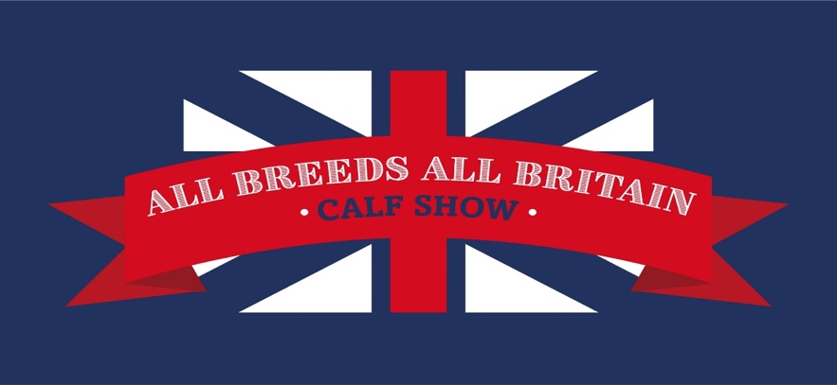

ALL BREEDS ALL BRITAIN CALF SHOW 2021

Friday 15th – Sunday 17th October

East of England Showground, Peterborough, PE2 6HE

**COLOURED BREEDS ENTRY FORM**

***ENTRIES RECEIVED AFTER WEDNESDAY 6th OCTOBER 2021 WILL NOT BE CONSIDERED***

Please forward entry forms & fees to the relevant Breed Society, headed All Breeds All Britain Calf Show 2021:

AYRSHIRE: Ayrshire Cattle Society, Westburn House, McNee Road, Prestwick, Ayrshire, KA9 2PB

[society@ayrshirescs.org](mailto:society@ayrshirescs.org)

BRITISH FRIESIAN: Holstein UK, Speir House, Stafford Park 1, Telford, Shropshire, TF3 3BD

[naomilewis@holstein-uk.org](mailto:naomilewis@holstein-uk.org)

BROWN SWISS: Clomendy, Llangain, Carmarthan, Carmarthanshire, SA33 5BB

[office@brownswiss.org](mailto:office@brownswiss.org)

DAIRY SHORTHORN: The Shorthorn Society, Stoneleigh Park, Kenilworth, Warwickshire, CV8 2RG

[claire@shorthorn.co.uk](mailto:claire@shorthorn.co.uk)

JERSEY: Jersey Cattle Society, Studio at the Mill, Mill Lane, Little Shrewley, Warwickshire, CV35 7HN [emmah@ukjerseys.com](mailto:emmah@ukjerseys.com)

GUERNSEY: The English Guernsey Cattle Society, Michaelmas Cottage, Meadwell Farm, Kelly, Lifton, Devon, PL16 0HJ

[office@guernseycattle.com](mailto:office@guernseycattle.com)

# SHOWMANSHIP CLASSES – FOC ENTRY

**CLASS NUMBER**

Name

DOB

Breed

**CLASS NUMBER**

Name

DOB

Breed

**CLASS NUMBER**

Name

DOB

Breed

**CLASS NUMBER**

Name

DOB

Breed

# CALF CLASSES - £15 PER ENTRY (ex British Friesians)

**CLASS NUMBER**

Breed Name

Sire Dam

DOB HB No

Exhibitor E-Mail _________________________________

Mobile Number___________________________ Exhibitor bred YES/NO

**CLASS NUMBER**

Breed Name

Sire Dam

DOB HB No

Exhibitor E-Mail _________________________________

Mobile Number___________________________ Exhibitor bred YES/NO

**CLASS NUMBER**

Breed Name

Sire Dam

DOB HB No

Exhibitor E-Mail _________________________________

Mobile Number___________________________ Exhibitor bred YES/NO

**CLASS NUMBER**

Breed Name

Sire Dam

DOB HB No

Exhibitor E-Mail _________________________________

Mobile Number___________________________ Exhibitor bred YES/NO

**CLASS NUMBER**

Breed Name

Sire Dam

DOB HB No

Exhibitor E-Mail _________________________________

Mobile Number___________________________ Exhibitor bred YES/NO

**CLASS NUMBER**

Breed Name

Sire Dam

DOB HB No

Exhibitor E-Mail _________________________________

Mobile Number___________________________ Exhibitor bred YES/NO

**CLASS NUMBER**

Breed Name

Sire Dam

DOB HB No

Exhibitor E-Mail _________________________________

Mobile Number___________________________ Exhibitor bred YES/NO

I hereby certify that the contents herein is correct to the best of my knowledge & belief, & I hereby agree to conform to & abide by the showing rules & regulations of the relevant Society, which have been read prior to me signing this form.

PREFIX:

BREED SOCIETY:

NAME:

SIGNATURE:

DATE: